**CHAWTECH SOLUTIONS PVT LTD**

**Google Ad words Proposal**

**(Pay per Click)**



A Business Proposal

|  |  |
| --- | --- |
| **Developed For:** | **-------** |

**Designed By:** ChawTech Solutions Private Limited

***PPC PROPOSAL***

|  |  |
| --- | --- |
| To,  **Mr. ____** | **Date: February 27, 2020** |

**Below are the activities which we will do on daily basis.**

**PPC PROPOSAL: Daily action**

**Total campaign –5**

**Keywords Analysis – 20 keywords for each campaign**

**Total 5 = 20*5= 100 keywords analysis for the campaign**

**Steps for the Google ad words (PPC)**

1. **Goal of the Campaign**

* **Traffic**
* **Leads**
* **Calls**

1. **Campaign creation**

* **Search Campaign**
* **Smart campaign**

1. **Competitor’s Analysis**
2. **Keywords Research Analysis**

**Keywords Analysis Points to keep in mind while running the Google Ads.**

* **Average Monthly searches**
* **Competition**
* **Suggested bid**
* **Quality score**

1. **Structure and organize your PPC keywords**
2. **Include negative keywords in your campaign**
3. **Campaign page creation**

**Number of projects –5**

1. **Landing page creation**
2. **Write better Ad copy creation**

* **Better ad creation: we will crafts some killer ads so it will make all the difference in terms of ROI.**

1. **There are number of extension we can feature in ads. Extensions make more visible your ads in SERPs.**

* **Site Extension**
* **Call extension**
* **Location extension**
* **App extension**
* **Review extension**
* **Callout extension**
* **Structured snippet extension**

1. **Competitor’s bidding Analysis**

**Keep an eye to competitors biding and their ads positions in SERPs. On daily basis so accordingly we can keep changing our strategy to come out first positions.**

1. **Set audience**

* **Age**
* **Gender**
* **Audience exclusion (can exclude the Audience)**

1. **Ad schedule**
2. **Ads Optimization score**

* **Analysis of ads optimization score is very important factor. We need to maintain the score on daily basis.**

1. **Locations to be targeted**
2. **Budget per Month**
3. **Bid strategy**

* **Estimated first page bid**
* **Estimated first position bid**

1. **Device setting**

**You can set the device option where you want your ads should be shown.**

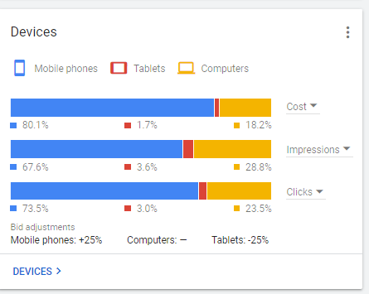

1. **Auction Insights**

**In auction insights we can check your ads frequency (impressions) in SERPs among your competitor’s.**

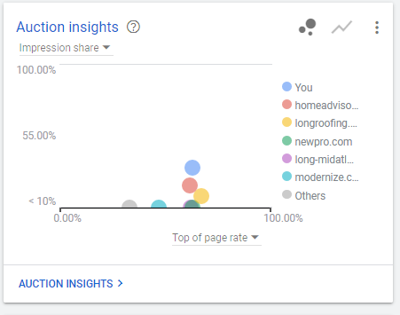

1. **Monitoring clicks and impression on daily basis to keep improving your campaign.**

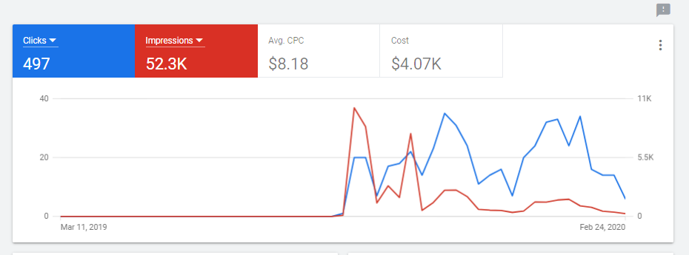

**Payment Option:**

**Two modes are available for the payment**

* **Manual Payment**
* **Automatic Payment**

**For Detailing about the Payment method kindly go through below link.**

<https://support.google.com/google-ads/answer/1704418?hl=en&ref_topic=3119102>

**Billing Information:**

**We will send you the link after creating your Google account for the payment option .after clicking the link you can directly pay to Google by using your account/card details. You can choose any mode for the payment.**

**Or else with your permission we can also make the payment by using our details after that we will share you the receipt provided by the Google. That payment mode will be totally transparent.**

the undersigned.

Thanking You,

Yours Sincerely

**Mr. Amit Chawla**

**Sales Head**

**Email – amit@chawtechsolutions.com**

**Skype – anshmahi1**

**Phone – +91 98960 25632**

**CHAWTECH SOLUTIONS PRIVATE LIMITED**

**ABOUT CHAWTECH SOLUTIONS**

ChawTech Solutions Pvt. Ltd is a determined IT consultancy headquarters based in India. Simply put, we bring to your business, immense growth prospects by making your presence felt on this sprawling marketing medium of internet. We first analyze the nature of your business and what exactly you are looking for. Then we decide the medium through which we can transform your business into a money-making entity. Whether it is designing a website, developing an application, redesigning of the existing website, content management or search engine optimization & submission, we have the provision of it all. Leveraging on our adroit professionals with an out of the box thinking temperament and latest technologies, our Internet marketing agency in India has all what it takes to deliver you nothing but the best.

***Our Mission***

Our mission is to touch the horizon where our capabilities may successfully meet with the requirements of our clients, that too with ultimate transparency and cost effectiveness.

***Our Vision***

To sow the seeds of par-excellence services with customer centric approach and reap the trust of worldwide clients.

***Core Values***

* **Transpicuous Work Culture –** Our words and actions always go hand-in-hand. We strongly preserve transparency to be correct ethically, legally and socially as well.
* **Result-Orientation –** By setting clear goals, fixing the priorities, organizing the resources-and rigorously monitoring the growth of project.
* **Customer-Centric Approach –** We revere the uniqueness of each client and his requirements and budget thus shape out the mirror-like solutions.
* **Innovation –** Think and do out of the box by setting the minds free. We also seek the unrevealed possibilities, hidden in feedbacks and suggestions of clients and co-workers.

**CHAWTECH SERVICES**

ChawTech Solutions Pvt. Ltd, offers a complete range of services pertaining to your web presence, from conceptualization till escorting you to the destination. The experience and expertise we have earned are not just matters of years passed rather they have nurtured our understanding of our client’s requirements.

Our zealous group of astute tech-savvies and the state-of-the-art infrastructure always set in mode of action to bring up the best possible web solutions. All these amalgamated with our customer-caring approach have generated a never-ending bond of trust between us and our clients. Our invincible expertise in rendering the services as per the clients’ requirements sets us apart from the rest. Delivering the mirror-like solutions for your imagination in the domain of e-business, we are driven by the mantra of “what you want is what we can”.

Our workforce is packed with highly skilled web designers, developers, copy writers, and SEO experts. This package assures you for hundred percent satisfactions. Approach towards meet the needs of the clients in a focused manner and adherence to the timely delivery of services has given us an edge over our peers in the market. Incessant investment in high-end technologies, human resources and for enhancement of the skills has accounted for higher returns for our clients backed up by integrity and security.

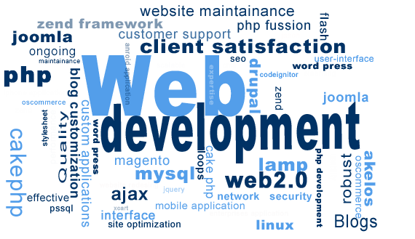

***How These Services Help You ?***

* Offer various modes to **emerge and get promoted in E-Business World**.
* Provide you an **appealing web presence**.
* Entertain your client **24X7**.
* Enable you to **snatch full potential from E-Business World**.
* Bless you with **ever-flourishing online business promotion.**
* Give you opportunities to **expose your business to online** crowd.
* Offer **Global Visibility** in less than the fare of air ticket to one country.
* Assist you to **increase on ROI**.
* Tune-in with **Hi-Technology** and make your stand far ahead from your competitors.
* **Gear-up your business** activities and turn them faster and smoother.

***How We Work – The Methodology***

ChawTech Solutions Pvt. Ltd technical team takes necessary steps to understand customer requirements, and then tailor complete solutions that deliver tangible value to the enterprise. The entire process involves listening customer ideas, delving into their concerns, and considering every aspect of the problem - from the underlying business processes to the importance of change management to the merits of various technologies. ChawTech Solutions Pvt. Ltd technical team then craft unique information systems that move your business forward and yield a measurable return on investment.

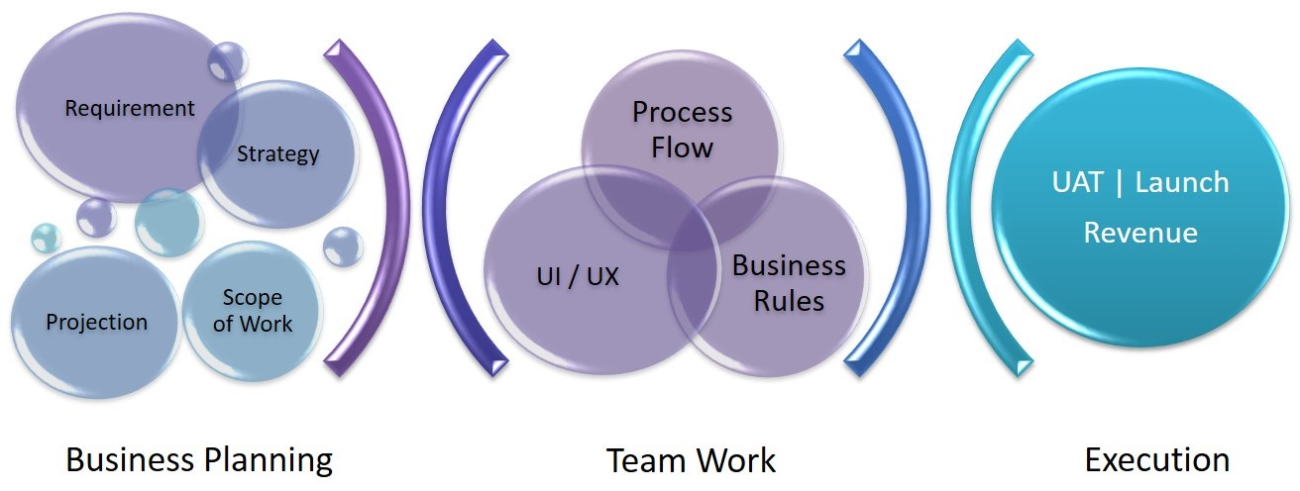

**CHAWTECH PRECIOUS CLIENTS**



**PROPOSED MODULES FOR WEBSITE AND MOBILE APPS**

|  |  |
| --- | --- |
| **[Disclosing Party]** | **[Receiving Party]** |
| **By: CHAWTECH SOLUTIONS PVT LTD** | **By: Genesis System** |
| Name: Mr. Amit Chawla | Name: Carlos Evora |
| Sales Head | Software Developer |
| Address: D-171, Sec-63, Noida (India)    Date: February 27, 2020 | Address: 13727 sw 152 street suite 304  Miami Fl 33177  Date: February 27, 2020 |
|  |  |

